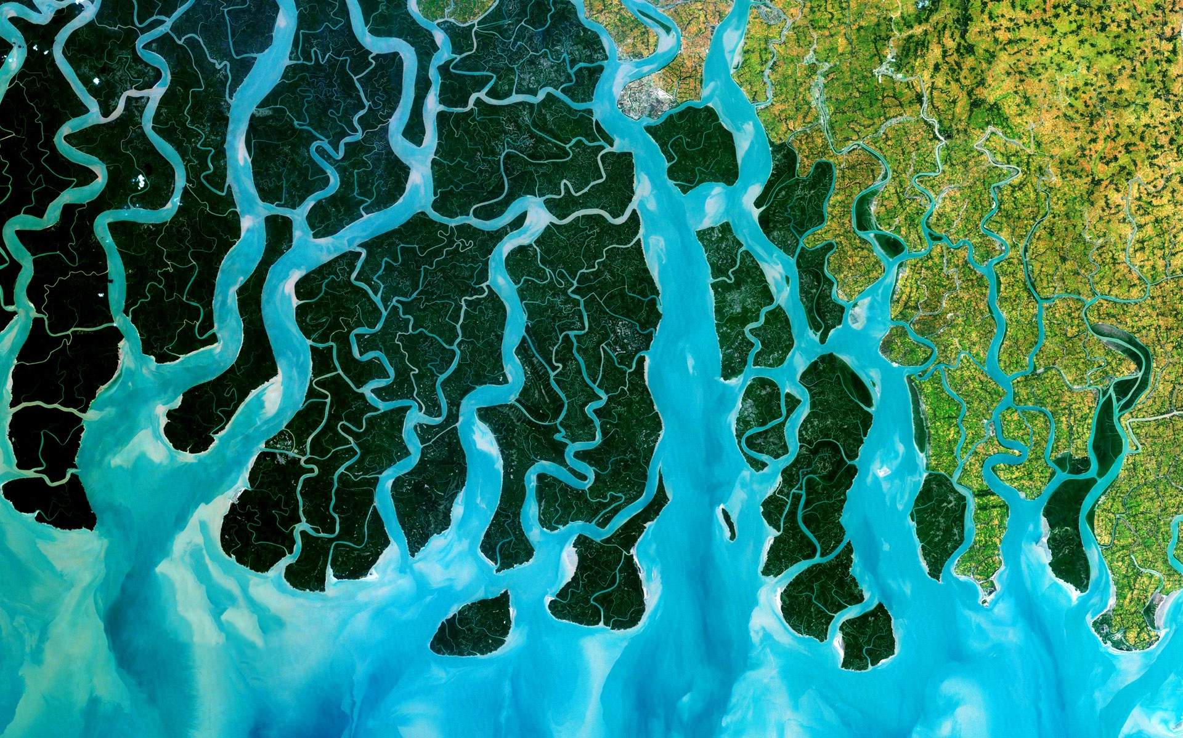

TERM 1 UNIT OUTLINE – GEOGRAPHY - 2024

YEAR 7 HASS

The concepts of [place](https://k10outline.scsa.wa.edu.au/home/p-10-curriculum/curriculum-browser/syllabus/humanities-overview/glossary/place), [space](https://k10outline.scsa.wa.edu.au/home/p-10-curriculum/curriculum-browser/syllabus/humanities-overview/glossary/space), environment, [interconnection](https://k10outline.scsa.wa.edu.au/home/p-10-curriculum/curriculum-browser/syllabus/humanities-overview/glossary/interconnection), sustainability and [change](https://k10outline.scsa.wa.edu.au/home/p-10-curriculum/curriculum-browser/syllabus/humanities-overview/glossary/change) continue to be developed as a way of thinking and provide students with the opportunity to inquire into the nature of water as a natural resource. The concept of [place](https://k10outline.scsa.wa.edu.au/home/p-10-curriculum/curriculum-browser/syllabus/humanities-overview/glossary/place) is expanded through students' investigation of the [liveability](https://k10outline.scsa.wa.edu.au/home/p-10-curriculum/curriculum-browser/syllabus/humanities-overview/glossary/liveability) of their own [place](https://k10outline.scsa.wa.edu.au/home/p-10-curriculum/curriculum-browser/syllabus/humanities-overview/glossary/place). They apply this understanding to a wide range of places and environments at the full range of scales, from [local](https://k10outline.scsa.wa.edu.au/home/p-10-curriculum/curriculum-browser/syllabus/humanities-overview/glossary/local) to global, and in a range of locations**.**

|  |  |  |  |  |  |
| --- | --- | --- | --- | --- | --- |
| **Year 7 - Geography Unit Outline – Term 1, Semester One 2019** | | | | | |
| **Water and the World** | | | | | |
| **Week** | **Notes** | **Lesson 1** | **Lesson 2** | **Lesson 3** | **Lesson 4** |
| *The classification of*[*environmental resources*](https://k10outline.scsa.wa.edu.au/home/p-10-curriculum/curriculum-browser/syllabus/humanities-overview/glossary/environmental-resources) *(renewable and non-renewable) (ACHGK037)* | | | | | |
| 1 |  | *SDD* | **Learning Intention (LI):** Introduce course – what is to be studied in Geography this term – Water and the World, Place and Liveability.  **Success Criteria (SC):** Able to explain why the study of geography is important with examples. | **Learning Intention (LI):** Introduce Geography and SPICESS Key Concepts (KC)  **Success Criteria (SC):** Can recall/define the definition of Geography. Able to list and provide examples of SPICESS. | **Learning Intention (LI):** Introduce Geography and SPICESS Key Concepts (KC)  **Success Criteria (SC):** Can recall/define the definition of Geography. Able to list and provide examples of SPICESS. |
| **Suggested Lesson Activities/Resources:**  Introduction to Geography and SPICESS PowerPoint and SPICESS Student Table worksheet (Learning Area Drive)  World Map Labelling Activity or BOLTSS Activity | **Suggested Lesson Activities:**  Intro. Geography and SPICESS PowerPoint (HASS Drive)  <https://www.youtube.com/watch?v=5FVgg_u3auA>  Concept map of key geographical concepts with definitions and examples  GLOSSARY – Definition of the study of Geography and they 2 branches of geography (human and physical)  **Suggested Resources:**  SCSA Concepts Diagram  SPICESS concept map Handout | Same as previous lesson.  Atlas Race as Do Now.  Catch up lesson if needed. |
| **Week** | **Notes** | **Lesson 1** | **Lesson 2** | **Lesson 3** | **Lesson 4** |
| *The quantity and variability of Australia's water resources compared with those in other continents (ACHGK039)* | | | | | |
| 2 |  | **LI:** Introduce *Water in the World* topic by starting with the classification of environmental resources.  **SC:** Students can define what a natural resource is.  Students to understand the difference between renewable and non-renewable resources. | LI: Understand the importance of water as a natural resource.  **SC:** Students can list ways that waters is used by humans | * **LI:** Understand process of the Water Cycle and it’s key elements (PERTIC)   **SC:** Able to label a diagram of the water cycle and list the processes involved (PERTIC) | LI: Use the PQE skill to describe the world’s freshwater resources  SC: Is able to list what PQE stands for  Can describe where the majority of the world’s fresh water is located |
| **Suggested Lesson Activities:**   * Define ‘*environmental resources’*. * Define ‘*renewable, non-renewable resources and continuous resources’.*   Construct a table on file paper using a red pen or pencil and a ruler, list examples for each type of resource.   |  |  |  | | --- | --- | --- | | Renewable  Resources | Non-renewable Resources | Continuous  Resources | |  |  |  |   Page 72-73 of Pearson HASS WA  P.42-43 Oxford WA  Resources Worksheet (Learning Area Drive) | **Suggested Lesson Activities:**   * Revise environmental resources and the three types * Thewaterweeat.com * Students come up with a water log * Investigate Indigenous water use (Oxford p. 78-79) * Brainstorm water use as a class | **Suggested Lesson Activities:**   * The Water Cycle – define what the water cycle is and look at the key elements of the water cycle. * Look at each process of the water cycle, such as PERTIC. (**Precipitation, Evaporation, Run-off, Transpiration, Infiltration, Condensation)** * Discuss and brainstorm the human impacts and how humans interact with the water cycle. * Link the water cycle to the big idea of quantity and variability of water resources. * Look at a diagram of the Water Cycle | **Suggested Lesson Activities:**   * P.48-49 Oxford Textbook Activity * P. 70-71 Oxford textbook. |

|  |  |  |  |  |  |  |
| --- | --- | --- | --- | --- | --- | --- |
| **Week** | **Notes** | **Lesson 1** | **Lesson 2** | | **Lesson 3** | **Lesson 4** |
| *The quantity and variability of Australia's water resources compared with those in other continents (ACHGK039)* | | | | | | |
| **3** |  | **Catch up lesson if needed!**  **Revise all previous content including water cycle, SPICESS, resources, PQE.** | **LI:** Understand ways that geographical data can be presented (table and graph) using climate graphs.  SC: Student is able to analyse and create a climate graph. | * **LI:** Understand the variability of water resources in Australia and other continents around the world.   **SC:** Able to describe the quantity and variability of water. | | **LI:** Understand water scarcity and the different types of water scarcity.  **SC:** Define and provide examples of Water Scarcity around the world and in Australia. |
| -Kahoot  -Revision quiz  -Mindmapping  -Give one, get one  -Audit of student notes | **Suggested Lesson Activities:**   * Oxford skills book p.8-9 * Oxford skills book p. 18-19 * Oxford textbook p.66-67 | **Suggested Lesson Activities:**   * Recap and review the definition of ‘water’. * Define the terms *quantity and variability, plus define and understand the names of the Worlds Continents. Mapping Skills: Incorporate direction. E.g. the direction of Australia from Africa*   Look at the concept of *groundwater.* Discuss the advantages and disadvantages of groundwater. Why is groundwater a renewable resource?  Define the term *aquifer. Discuss where the world’s aquifers are located.*  **Resources:**  Water Variability PowerPoint  Pearson HASS WA 7. (Pages 78-79) | | **Suggested Lesson Activities:**   * Water Scarcity – look at types of water scarcity. Page 90-91 Pearson HASS WA 7. * Case Study – Water scarcity in Africa. * Define the following terms – scarcity, desalination, consumption, water recycling. * -Reasons for water scarcity in areas around the world * -Water scarcity in Africa (Page 126-127) * -Water scarce in west-Asia and North Africa (Page 128-129) * -Water crises in West Asia (Page 130-131) * Complete activity 5 a b c page 91 of Pearson HASS WA 7. * Brainstorm what we use water for. Complete a Think-Pair-Share. * Look at types of water – Blue Water, Green Water and Grey Water. * Complete activity 5 page 93. |
| **Week** | **Notes** | **Lesson 1** | **Lesson 2** | | **Lesson 3** | **Lesson 4** |
| *The quantity and variability of Australia's water resources compared with those in other continents (ACHGK039)* | | | | | | |
| **4** | **Assessment 1** | **LI:** Understand water scarcity and the different types of water scarcity.  **SC:** Define and provide examples of Water Scarcity around the world and in Australia. | **LI:** Learn about the concept of a water footprint.  **SC:** Able to describe what a foot print is, with reference to a case study. | **Revision/ Catch up Lesson** | | ***Assessment Task 1 – In Class Test***  A combination of multiple choice and short answer response questions focusing on content from Weeks 1-4*. Content may include Geographical Concepts (SPICESS), Renewable and Non-Renewable Resources, The Water Cycle, Climate Graphs.* |
| **Suggested Lesson Activities:**   * Water Scarcity – look at types of water scarcity. Page 90-91 Pearson HASS WA 7. * Case Study – Water scarcity in Africa. * Define the following terms – scarcity, desalination, consumption, water recycling. * -Reasons for water scarcity in areas around the world * -Water scarcity in Africa (Page 126-127) * -Water scarce in west-Asia and North Africa (Page 128-129) * -Water crises in West Asia (Page 130-131) * Complete activity 5 a b c page 91 of Pearson HASS WA 7. * Brainstorm what we use water for. Complete a Think-Pair-Share. * Look at types of water – Blue Water, Green Water and Grey Water. * Complete activity 5 page 93. | **Suggested Lesson Activities:**  Content:  What is meant by a water footprint?  -Do water footprints vary?  -Coca-Cola and their water footprint (page 10-11)  -Brainstorm – what do you use water for? | Kahoots | |  |

|  |  |  |  |  |  |  |
| --- | --- | --- | --- | --- | --- | --- |
| **Week** | **Notes** |  | **Lesson 2** | | **Lesson 3** | **Lesson 4** |
|  | | | | | | |
| **5** |  | **LI:** Understand the concept of Liveability  **SC:** Define Liveability  Identify factors which influence where people live | **LI:** Explore the worlds most liveable cities.  **SC:**Identify the most liveable cities  Discuss what makes these cities more liveable. | LI: Explore the factors that affect people’s perceptions of liveability.  SC: Identify and describe factors that can affect people’s perceptions of liveability. | | **LI:** Explore the factors that affect people’s perceptions of liveability.  **SC:** Identify and describe factors that can affect people’s perceptions of liveability. |
| Begin Depth Study 2:Place and Liveability  - Define ‘liveability’. Page 120 Pearson 7  - Deciding where to live (Page 110-111 Pearson 7) Look at the factors affecting the choices people make about where they live. Create a mind map showing the various factors. Create a list that ranks the factors.  - What influences the liveability of places? | Map the top 10 and bottom 10 liveable cities in the world using the latest data from the EIU Global Liveability Index (2021 results).  Students are to ensure their map has BOLTSS features.  Discuss as a class the spatial distribution of liveable cities. How has COVID potentially impacted these? | factors which can affect people’s perceptions of liveability.  What are perceptions  What influences someones perceptions?  Factors that impact liveability  Does liveabiltiy differ between groups ie. age | | factors which can affect people’s perceptions of liveability.  What are perceptions  What influences someones perceptions?  Factors that impact liveability  Does liveabiltiy differ between groups ie. age |

|  |  |  |  |  |  |  |
| --- | --- | --- | --- | --- | --- | --- |
| **Week** | **Notes** | **Lesson 1** | **Lesson 2** | | **Lesson 3** | **Lesson 4** |
| *The factors that influence the decisions people make about where to live and their perceptions of the* [*liveability*](http://k10outline.scsa.wa.edu.au/home/p-10-curriculum/curriculum-browser/humanities-and-social-sciences/humanities-overview/glossary/liveability) *of places (*[*ACHGK043*](http://www.scootle.edu.au/ec/search?accContentId=ACHGK043)*)*  *The influence of accessibility to* [*services*](http://k10outline.scsa.wa.edu.au/home/p-10-curriculum/curriculum-browser/humanities-and-social-sciences/humanities-overview/glossary/services) *and facilities on the* [*liveability*](http://k10outline.scsa.wa.edu.au/home/p-10-curriculum/curriculum-browser/humanities-and-social-sciences/humanities-overview/glossary/liveability) *of places (*[*ACHGK044*](http://www.scootle.edu.au/ec/search?accContentId=ACHGK044)*)* | | | | | | |
| **6** |  | **LI:** Understand how remoteness can impact liveability.  **SC:** Outline what the term remoteness means.  Describe how remoteness can impact liveability. | **LI:** Explore strategies that can be used to enhance liveability.  **SC:** Identify a strategy from Australia and one from Europe that can enhance liveability.  Outline how these strategies enhance liveability. | **LI:** Understand the importance of and how to complete a Bibliography and other geographical skills.  **SC:** Complete a bibliography according to school proforma. | | Assessment 2 |
| Remoteness (access to services) and how this can impact liveability.  Pearson p. 118 | **Strategies to enhance Liveability**  -New York Highline  -Innovative schools  -Enhancing public spaces  -Greener cities  -Before and after pictures of spaces and analysing what has changed to enhance liveability? | **Skills Lesson**  **Bibliography**  **Explain assignment etc.** | |  |

|  |  |  |  |  |  |  |
| --- | --- | --- | --- | --- | --- | --- |
| **Week** | **Notes** | **Lesson 1** | **Lesson 2** | | **Lesson 3** | **Lesson 4** |
| *The factors that influence the decisions people make about where to live and their perceptions of the* [*liveability*](http://k10outline.scsa.wa.edu.au/home/p-10-curriculum/curriculum-browser/humanities-and-social-sciences/humanities-overview/glossary/liveability) *of places (*[*ACHGK043*](http://www.scootle.edu.au/ec/search?accContentId=ACHGK043)*)*  *The influence of accessibility to* [*services*](http://k10outline.scsa.wa.edu.au/home/p-10-curriculum/curriculum-browser/humanities-and-social-sciences/humanities-overview/glossary/services) *and facilities on the* [*liveability*](http://k10outline.scsa.wa.edu.au/home/p-10-curriculum/curriculum-browser/humanities-and-social-sciences/humanities-overview/glossary/liveability) *of places (*[*ACHGK044*](http://www.scootle.edu.au/ec/search?accContentId=ACHGK044)*)* | | | | | | |
| **7** |  | Assessment 2 | Assessment 2 | Assessment 2 | | **Assessment 2** |
| Students to work on completing their 2nd assessment (portfolio item)  Likely will need to book computers  Assessment to be found on Learning Area Drive.  Measure students progress using checklist | | | | |

|  |  |  |  |  |  |  |
| --- | --- | --- | --- | --- | --- | --- |
| **Week** | **Notes** | **Lesson 1** | **Lesson 2** | **Lesson 3** | | **Lesson 4** |
| *The factors that influence the decisions people make about where to live and their perceptions of the* [*liveability*](http://k10outline.scsa.wa.edu.au/home/p-10-curriculum/curriculum-browser/humanities-and-social-sciences/humanities-overview/glossary/liveability) *of places (*[*ACHGK043*](http://www.scootle.edu.au/ec/search?accContentId=ACHGK043)*)*  *The influence of accessibility to* [*services*](http://k10outline.scsa.wa.edu.au/home/p-10-curriculum/curriculum-browser/humanities-and-social-sciences/humanities-overview/glossary/services) *and facilities on the* [*liveability*](http://k10outline.scsa.wa.edu.au/home/p-10-curriculum/curriculum-browser/humanities-and-social-sciences/humanities-overview/glossary/liveability) *of places (*[*ACHGK044*](http://www.scootle.edu.au/ec/search?accContentId=ACHGK044)*)* | | | | | | |
| **8** |  | Assessment 2 | **Assessment 2** | | **Assessment 2** | **Assessment 2** |
| Students to work on completing their 2nd assessment (portfolio item)  Likely will need to book computers  Assessment to be found on Learning Area Drive.  Measure students progress using checklist | | | | |

|  |  |  |  |  |  |  |
| --- | --- | --- | --- | --- | --- | --- |
| **Week** | **Notes** | **Lesson 1** | **Lesson 2** | **Lesson 3** | | **Lesson 4** |
| *The factors that influence the decisions people make about where to live and their perceptions of the* [*liveability*](http://k10outline.scsa.wa.edu.au/home/p-10-curriculum/curriculum-browser/humanities-and-social-sciences/humanities-overview/glossary/liveability) *of places (*[*ACHGK043*](http://www.scootle.edu.au/ec/search?accContentId=ACHGK043)*)*  *The influence of accessibility to* [*services*](http://k10outline.scsa.wa.edu.au/home/p-10-curriculum/curriculum-browser/humanities-and-social-sciences/humanities-overview/glossary/services) *and facilities on the* [*liveability*](http://k10outline.scsa.wa.edu.au/home/p-10-curriculum/curriculum-browser/humanities-and-social-sciences/humanities-overview/glossary/liveability) *of places (*[*ACHGK044*](http://www.scootle.edu.au/ec/search?accContentId=ACHGK044)*)* | | | | | | |
| **9** |  | **Assessment 2** | **Assessment 3** | | **CARNIVAL** | ***NO LESSON*** |
| Measure students progress using checklist  Work with students to ensure that they are able to submit their portfolio items. | Students complete Validation Task | | Assessment 3  Validation Task | GOOD FRIDAY |

Please note that content can be extended into Term 2, Week 1. May need to do this for the assessment.

See where students are at in Term 1.